DESSERTS
Please choose one of the following
CHOCOLATE CRUNCHY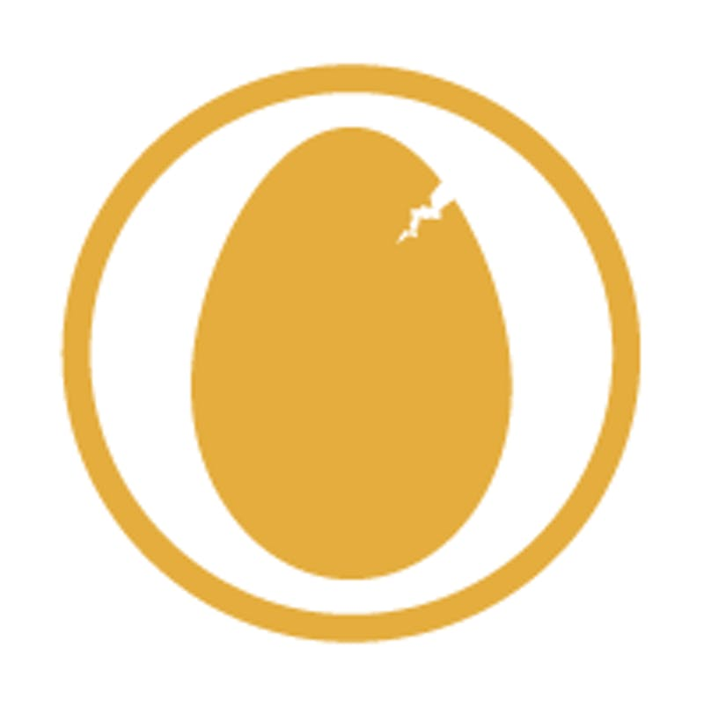
Thai Legend most popular dessert. Two tiers of layered of sponge, chocolate whipped cream and honey combe with splashed of liquor.
FRESH FRUIT SALAD
Mixed of seasonal yet refreshing fruits in Thai Legend special syrup.
GINGER CREAM
Layers of ginger nut biscuits and liquor whipped cream topped with grated ginger biscuits pieces.
RASPBERRY MERIGUE
A different take on the classic. Thai Legend raspberry meringue has a sponge based with whipped cream and topped with fresh raspberries.
SUMMER PUDDING
A citrus yet sweet and very berry desserts. Layers of breads soaked in homemade mixed summer berries sauce, topped with seasonal fruits.
ORANGES SLICES IN GRAND MARNIER
Fresh slices of oranges in homemade Grand Marnier sauce.

All served with or without single cream or with a scoop of vanilla ice – cream + £1.00.

TEA / COFFEE
House Coffee | English Breakfast Tea | Jasmine Tea | Earl Grey Tea| Green Tea
(Any allergies please inform our staff members)


This New Year’s Banquet special set menu serves with a glass of Prosecco
£55.00 PER PERSON
(Minimum order for two)

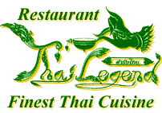
THAI LEGEND NYE BANQUET 

THAI LEGEND MIXED STARTERS
Selections of authentic Thai starters, served with variety of sauces

OR

AROMATIC CRISPY DUCK
Served with pancakes, sliced cucumbers, spring onions and hoisin sauce
KING PRAWNS OR CHICKEN TOM YUM SOUP
Choice between River prawns or Chicken in traditional Thai spicy hot and sour soup flavoured with lemon grass, lemon juice, lime leaves and coriander
GAENG KIEW WAN GAI
Chicken in green curry paste with coconut milk, Thai aubergines, and herbs.

MOO PHAD PRIEW WAN
Stir fried pork with pineapples, onions, peppers, and cucumbers in sweet and sour sauce.

NUEA PHAD BAI GAPRAO
Strips of steak stir fried with chilli, garlic, and fresh Thai basil.

PHAD PAK NAMMUN HOY
Stir fried seasonal vegetables with OR without oyster sauce.

Served with a choice between
KHAO SUAY OR KHAO PHAD KHAI
Thai steamed jasmine rice OR Thai fried rice with egg and fresh herbs

