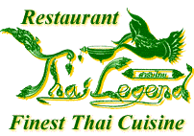
VALENTINE’S SPECIAL SET MENU
Serves with a glass of Prosecco.

THAI LEGEND MIXED STARTERS
A Selection of authentic Thai Starters, served with variety of sauces

OR

AROMATIC CRISPY DUCK
Served with pancakes, sliced cucumbers, spring onions and hoisin sauce.

GAENG PHED PED YAANG
Roast duck breast sliced cooked with red curry paste coconut milk, tomatoes,
pineapple pieces, Thai aubergines, fresh chilli Thai basil

GAI PHAD PRIK SOD
Marinated chicken stir fried with sliced chilli, garlic, onion, and spring onions.

PLA PRIEW WAN
Cubes of cod pieces deep fried and coated with sweet and sour sauce.

PHAD PAK NAMMAN HOY
Stir fried seasonal vegetables with OR without oyster sauce.

KHAO SUAY
Thai steamed jasmine ric
DESSERTS + TEA / COFFEE
£30.95 per person
(Minimum order for two people)

