DESSERTS
Please choose one of the following
CHOCOLATE CRUNCHY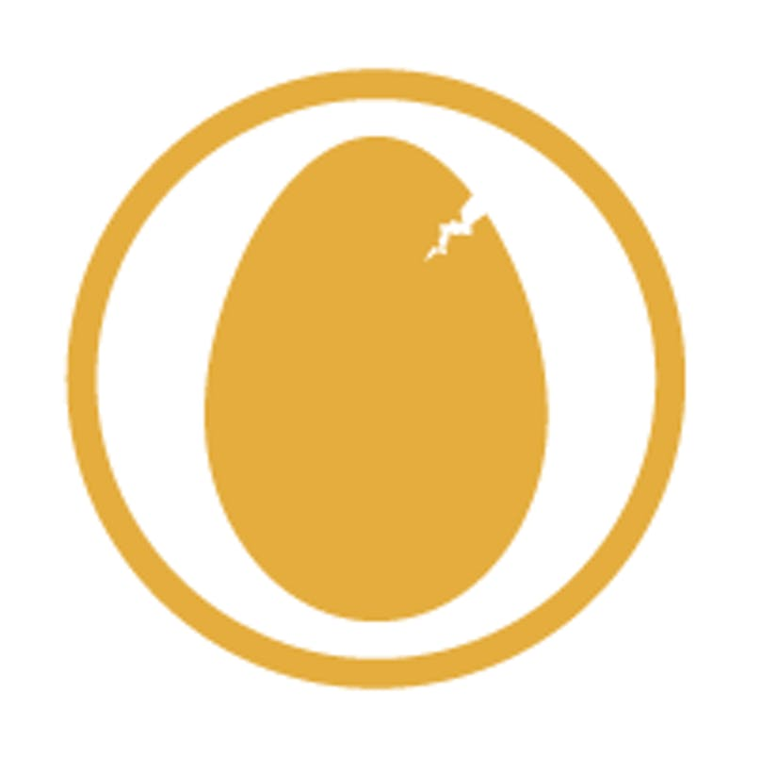
Thai Legend most popular dessert. Two tiers of layered of sponge, chocolate whipped cream and honey combe with splashed of liquor.
FRESH FRUIT SALAD
Mixed of seasonal yet refreshing fruits in Thai Legend special syrup.
GINGER CREAM
Layers of ginger nut biscuits and liquor whipped cream topped with grated ginger biscuits pieces.
RASPBERRY MERIGUE
A different take on the classic. Thai Legend raspberry meringue has a sponge based with whipped cream and topped with fresh raspberries.
SUMMER PUDDING
A citrus yet sweet and very berry desserts. Layers of breads soaked in homemade mixed summer berries sauce, topped with seasonal fruits.
ORANGES SLICES IN GRAND MARNIER
Fresh slices of oranges in homemade Grand Marnier sauce.

All served with or without single cream or with a scoop of vanilla ice – cream + £1.00.

TEA / COFFEE
House Coffee | English Breakfast Tea | Jasmine Tea | Earl Grey Tea| Green Tea
(Any allergies please inform our staff members)

£32.95 PER PERSON
(Minimum order for two)

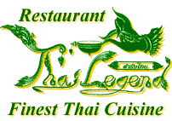
THAI LEGEND CHRISTMAS BANQUET 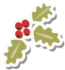

THAI LEGEND MIXED STARTERS
Selections of authentic Thai starters, served with variety of sauces

OR

AROMATIC CRISPY DUCK
Served with pancakes, sliced cucumbers, spring onions and hoisin sauce.
GAENG MASAMUN GAI
Chicken cooked with onion, potatoes, milk, Thai curry rich in spices but quite mild even sweetened.

PED PHAD KHING
Roasted duck stir fried with ginger, garlic, fresh chili sliced, spring onions, Chinese mushrooms, and celery.

GOONG PHAD NAMPRIK PAO
King prawns stir fried with chili paste, mixed peppers, mushrooms, and spring onion.

PHAD PAK NAMMUN HOY
Stir fried seasonal vegetables with OR without oyster sauce.

Served with a choice between
KHAO SUAY OR KHAO PHAD KHAI
Thai steamed jasmine rice OR Thai fried rice with egg and fresh herbs.

